**UML DIAGRAMS**

**CLASS DIAGRAM**

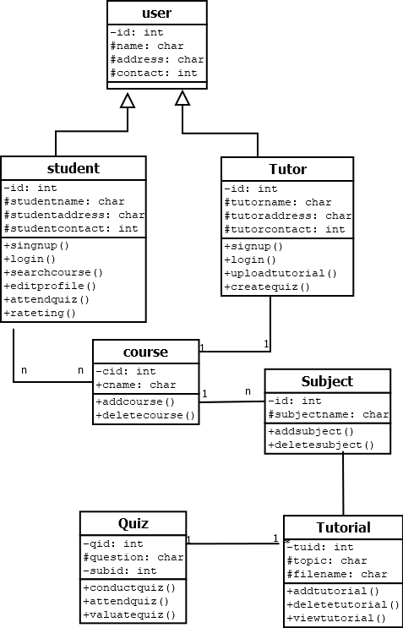

**OBJECT DIAGRAM**

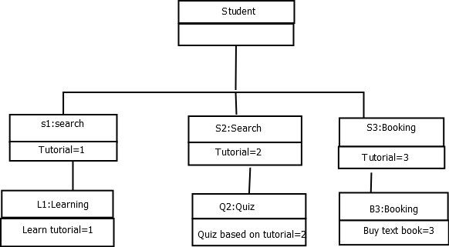

**COLLABORATION DIAGRAM**

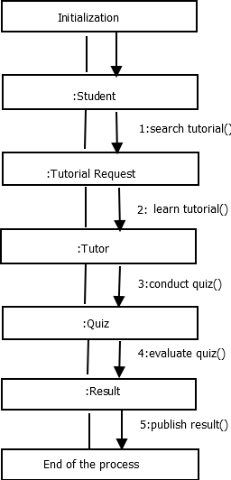

**DEPLOYMENT DIAGRAM**

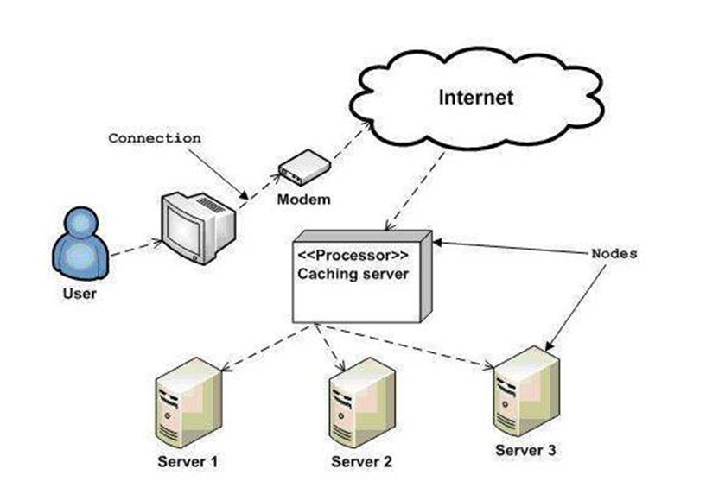

**STATE DIAGRAM**

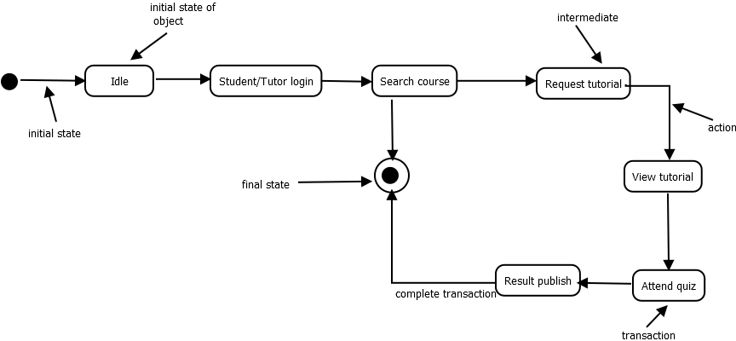

**ACTIVITY DIAGRAM**

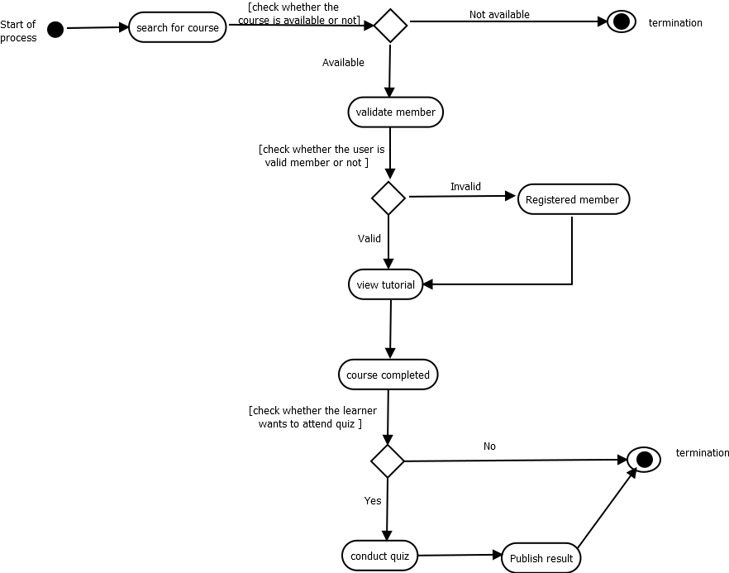

**SEQUENCE DIAGRAM**

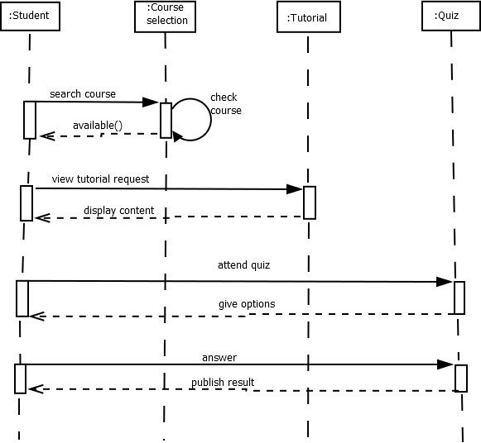

**USECASE DIAGRAM**

